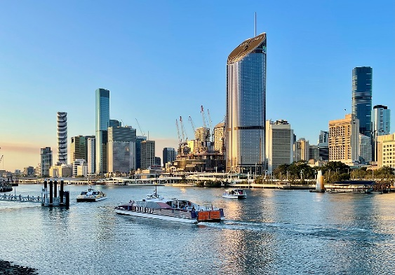

**CALL FOR SPECIAL SESSIONS**

Important dates

30th May 2024

Deadline for special session proposals

15th July 2024

Deadline for submission of digest

The 9th IEEE Southern Power Electronics Conference, SPEC 2024, offers an ideal opportunity for researchers, engineers, academics, and students from all over the world to bring the latest technological advances and applications in Power Electronics to the Southern Hemisphere, as well as to network and promote the discipline.

**Special Sessions:** Special sessions provide an opportunity to focus on emerging technologies and industry-oriented topics or represent a specific working field where researchers meet and discuss innovations and breakthroughs in highly specialized topic areas (within the conference’s scope). These sessions will broaden the knowledge base of attendees, helping them stay updated with recent advances in the power electronics domain. The SPEC 2024 organizing committee invites professionals in the areas of power electronics to propose special sessions (SSs) to be held at SPEC 2024.

**Proposal Content:** The special session’s proposal content should include the following information (as mentioned in the MS word template downloadable from the SPEC 2024 official website): 1. Title of the Special Session. 2. Brief description of the area of concern (~100 words), with special emphasis on why this is an interesting and significant topic. 3. Name and contact information of special session organizers (preferably 2 to 3) who are willing to promote and organize a sufficient amount of quality submissions to the special session. 4. Brief biography and photos of the organizers. 5. A list of potential authors and their affiliations. 6. A list of potential reviewers and their affiliations (20 minimum).



#### ****General Chair****

Mahinda Vilathgamuwa

**General Co-Chair**

Sarath Tennakoon  
Udaya Madawala  
Junwei Lu

#### ****Technical Program Chair****

Dezso Sera

#### ****Technical Program Co-Chairs****

Gamini Jayasinghe

Yang Li

Chandana Gajanayake

Organization of Special Sessions

Once approved, the Organizers will publicize the Special Session among researchers and practitioners in the field and attract sufficient number of papers. Papers submitted to special sessions will undergo the same review process as regular papers. The special session organizers of the respective special session are responsible for organizing the review process, assuring at least three reviews per paper. This includes selection of reviewers from their peers.

**Free Conference Registration:** At least one organizer of the successful Special Sessions is expected to register for and attend the conference, as well as chair the corresponding sessions. One complimentary full registration will be provided to successful Special Sessions with at least 6 papers not authored by any of the organizers.

**Conflict of Interest:** Before starting the review process, SS organizers must explicitly declare papers which present a conflict of interest for them. A conflict of interest arises where the judgement of a paper quality can be influenced by the organizers being authors or knowing some of the authors. To ensure independent reviews, this conflict must be marked as such in the submission system and the SS Co-Chairs notified so that they can arrange the review process.

**Restrictions:** During the review process, Special Session Organizers must take into account that: (1) An individual cannot be (co-) author of more than two papers submitted to the same Special Session. (2) Papers from organizers cannot exceed 60% of the contents of the Special Session.

**Session Chairs:** When a SS is finally accepted by the conference, SS organizers will serve as Session chairs in the conference. In some extenuated circumstance, Technical Program chairs and Conference General Chairs might take up the full control of appointing the Session Chairs, should the SS organizers be unable to participate in the conference. Proposal Submission: Please send your proposal in PDF format on the e-mail address [ieeespec2024@gmail.com](mailto:ieeespec2024@gmail.com). Special session proposals will be accepted from April 1 until May 30, 2024. We encourage early proposal submission to receive early decisions and higher number of paper submissions.